Irfan Momin

Thursday, 07th September 2023

This guide contains Installation and artifacts deployment steps of   
Tomcat, React, MySQL, Nginx, Pod-man.

**Prolifics Corporation Ltd**

**PPMbeta Installation & Deployment Guide V1.0**

**Document Control**

The following table identifies those to whom this document has been distributed for review.

|  |  |
| --- | --- |
| **Document Details** | |
| **Author** | Irfan Momin |
| **Company** | Prolifics |

|  |  |
| --- | --- |
| **Document Distribution** | |
| **Name** | **Role** |
| Prolifics | Internal Automation Team,  IT team,  Infrastructure Team. |

|  |  |  |  |
| --- | --- | --- | --- |
| **Version and Distribution History** | | | |
| **Version No** | **Date** | **Brief Comments on Change** | **Authors** |
| 1.0 | 07-September-2023 | Initial Draft | Irfan Momin |
|  |  |  |  |
|  |  |  |  |

|  |  |  |
| --- | --- | --- |
| **Document Reviewers Sign Off** | | |
| **Name** | **Signature** | **Date** |
| Rajeev Sharma | Senior Architect |  |
| Moses Srikanth Jonnakuti | Senior Test Lead |  |
| Rajeswari Kanupuru | Associate Test Lead |  |
|  |  |  |

|  |  |  |
| --- | --- | --- |
| **Document Approvals Sign Off** | | |
| **Name** | **Signature** | **Date** |
| Varun Sharma | Business Architect |  |
|  |  |  |
|  |  |  |
|  |  |  |

Table of Contents

**1.Production Environment04**

1.1 Server Details04

1.2 Prerequisite Information 04

1.3 PPM Overview and Architecture05

1.4 Data Flow Tier Diagram06

**2.Software Installation 07**

2.1 Java 8 Installation07

2.2 Update Ubuntu Packages08

2.3 MySQL Installation08

2.3.1 Check Prerequisite08

2.3.2 Download Installation file08

2.3.3 Extract Installation file08

2.3.4 Debian Package Installation09

2.3.5 Dependency Packages Installation09

2.3.6 Fix Broken Package09

2.3.7 Create Root Password10

2.3.8 Check Status and Commands10

2.3.9 Create Database11

2.3.10 Extract Database11

2.3.11 Test Database Connection11

2.3.12 Run query and SP to Verify Database11

2.4 Apache Tomcat Installation11

2.4.1 Check Prerequisite11

2.4.2 Create Tomcat Users and Groups11

2.4.3 Download Tomcat Installer11

2.4.4 Set Permission12

2.4.5 Create SystemD unit file12

2.4.6 Check Status and Commands13

2.4.7 Configure the Firewall13

2.4.8 Configure the Web Management Interface13

2.4.9 Testing Tomcat14

2.5 Nginx Installation16

2.5.1 Check Prerequisite 16

2.5.2 Install Nginx16

2.5.3 Verify Installation16

2.5.4 Check Status and Commands16

2.5.5 Configure Firewall17

2.5.6 Test Connection17

2.5.7 Modify Nginx Configuration17

2.5.8 Nginx Configuration for React Code Hosting18

2.5.8 Remove Nginx18

2.6 Podman Installation19

2.6.1 Check Prerequisite 19

2.6.1 Install Podman19

2.6.1 Check Status and Commands19

**3.Deployment20**

3.1 React Code Hosting20

3.2 Podman Deployment21

3.2.1 Create required directories21

3.2.2 Copy Jar22

3.2.3 Build Images22

3.2.4 Run Image22

3.2.5 Check Jar22

3.3 Microservices Deployment23

3.3.1 Manual deployment through Tomcat Manager23

3.3.1 Automatic deployment through Jenkins24

**4.Testing28**

4.1 Black Box testing28

4.1.1 UI Testing28

4.1.2 Functionality Testing29

4.1.3 Performance Testing29

**1.Production Environment**

1.1 Server Details

In Production environment there will be 3 nodes as below table.

|  |  |  |  |  |  |
| --- | --- | --- | --- | --- | --- |
| **Image Name** | **Host Name** | **IP Address** | **RAM** | **Cores** | **Software** |
| Web Server | - | 10.11.12.141 | 16 | 4 | Nginx, TomcatV1, API Gateway, Podman |
| Application Server | - | 10.11.12.142 | 16 | 4 | TomcatV2 |
| Back-end Server | - | 10.11.12.143 | 16 | 4 | MySQL |

1.2 Prerequisite Information

WinSCP - Version 5.21.6

PuTTY - Version 0.78

Ubuntu - Version 20.04

MySQL - Version 5.6

Tomcat – 9

Java 11

1.3 PPM Overview and Architecture

PODMAN

10.11.12.141:9191

10.11.12.141:3000

10.11.12.141:80

**PPmbeta.prolifics.com /10.11.12.141:443**

ppmiams.prolifics.com

C

L

I

E

N

T

N

G

I

N

X

A

P

I

G

A

E

T

W

A

Y

SERVICE REGISTRY

10.11.12.142:8090

1.ACCOUNTINGMS

2.ADMINISTRATIONMS

3.COMMONMS

4.COSTMS

5.CUSTOMERMS

6.DASHBOARDMS

7.FULLFILMENTMS

8.GOVERNANCEMS

9.INVOICEMS

10.LAYOUTMS

11.PROJECTMS

12.REPORTMS

13.REVENUEMETRICSMS

14.SALESMS

15.SUPPORTMS

16.TEAMMS

17.TIMEANDEXPENSESMS

18.UTILITYMS

19.VENDORMS

Microservice’s

10.11.12.142:8080

MySQL

10.11.12.143:3306

Data Feeds

PEP DB,

Sales force, Projector

1.4 Data Flow Tier Diagram

Podman

Client Tier -141

Business Logic -142

Database Tier -143

React / Nginx

API Gateway youtApp.2023-09-05.0.log SalesError.2023-09-01.0.log

accountingError.log LayoutApp.log SalesError.2023-09-04.0.log

administrationApp.log LayoutEnvironment.log SalesError.2023-09-05.0.log

administrationError.log ProjectApp.log SalesError.log

CommonApp.2023-09-05.0.log ProjectEnvironment.2023-09-01.0.log ServiceApp.log

CommonApp.log ProjectEnvironment.2023-09-04.0.log ServiceEnvironment.log

CommonError.2023-09-05.0.log ProjectEnvironment.2023-09-05.0.log teamApp.log

CommonError.log ProjectEnvironment.log teamError.log

CostApp.log reportApp.2023-09-01.0.log timeandexpensesApp.2023-09-01.0.log

CostError.log reportApp.2023-09-04.0.log timeandexpensesApp.log

customersApp.2023-09-01.0.log reportApp.log timeandexpensesError.2023-09-01.0.log

customersApp.2023-09-04.0.log reportError.2023-09-01.0.log timeandexpensesError.2023-09-05.0.log

customersApp.log reportError.2023-09-04.0.log timeandexpensesError.log

customersError.2023-09-01.0.log reportError.log UtilityApp.log

customersError.2023-09-04.0.log revenuemetricsApp.log UtilityEnvironment.log

customersError.log revenuemetricsError.2023-09-05.0.log VendorApp.2023-09-01.0.log

dashboardsError.log revenuemetricsError.log VendorApp.log

fullfilmentApp.log SalesApp.2023-09-01.0.log VendorError.2023-09-01.0.log

fullfilmentError.log SalesApp.2023-09-04.0.log VendorError.log

invoiceApp.log SalesApp.2023-09-05.0.log

invoiceError.log SalesApp.log

Presentation /Browser

Micro Services

Application layer

Database Layer

MySQL

HTTP Request

HTML PAGE

Request Data

MySQL Data

**2.Software Installation**

* 1. Java 8 Installation
     1. Check java version.

java –version

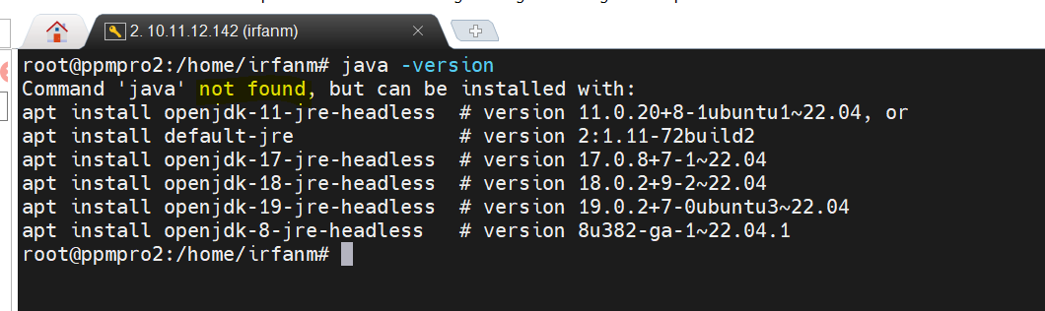

* + 1. Install Java.

apt install openjdk-8-jre-headless

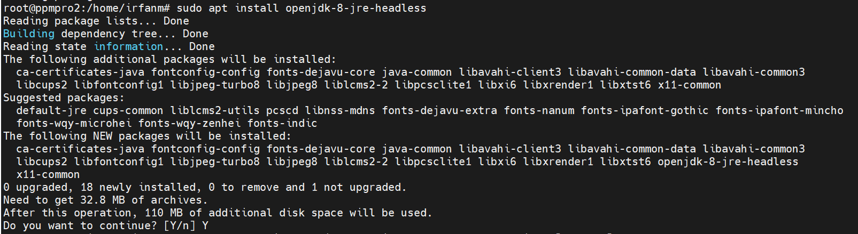

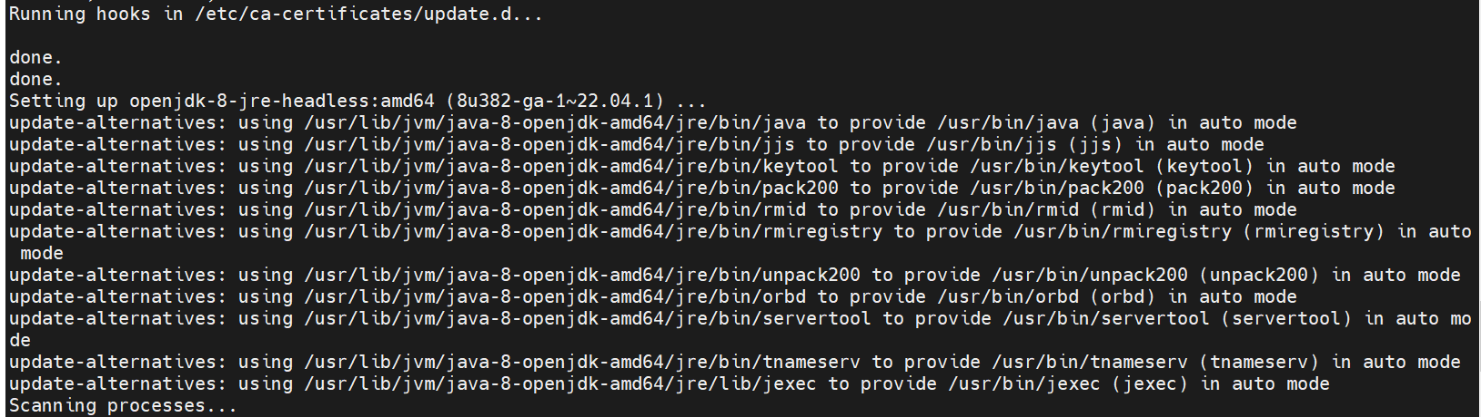

* + 1. Check Installed version.

java -version

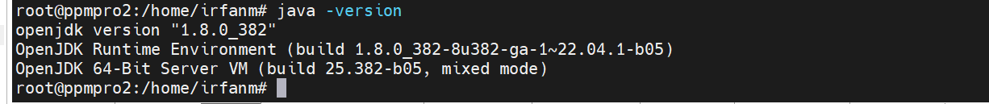

* + 1. Set Java Home path.

pdate-alternatives --config java

sudo vim /etc/environment

$JAVA_HOME="/usr/lib/jvm/java-1.8.0-openjdk-amd64/jre/bin "

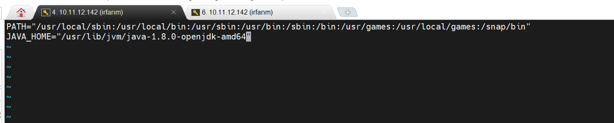

source /etc/environment

* + 1. Check Java Home Path.

echo $JAVA_HOME



* 1. Update Ubuntu Packages

sudo apt-get update

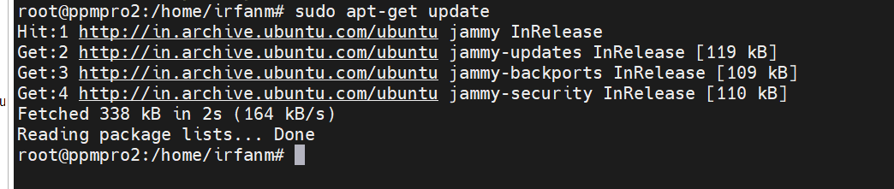

2.3 MySQL Installation

2.3.1 Check Prerequisite

a. Java 8 installed.

If java is not installed, please refer section 2.1.2 for java installation.

b. Ubuntu package updated.

Refer section 2.1.3 for update.

2.3.2 Download Installation file

wget h<ttps://dev.mysql.com/get/Downloads/MySQL-5.6/mysql-server_5.6.48-1>debian9_amd64.deb-bundle.tar

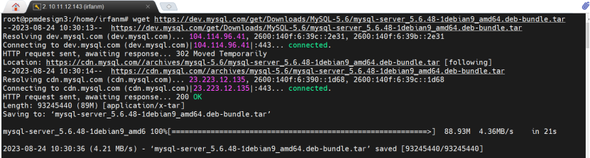

2.3.3 Extract Installation file

tar xvf mysql-server_5.6.48-1debian9_amd64.deb-bundle.tar

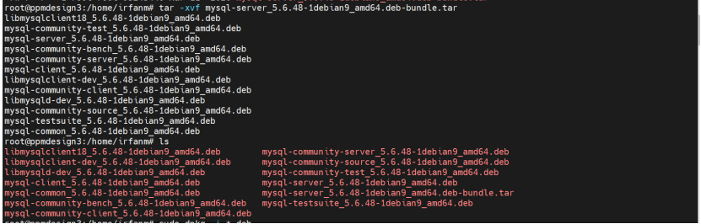

2.3.4 Debian Package Installation

sudo dpkg -i *.deb

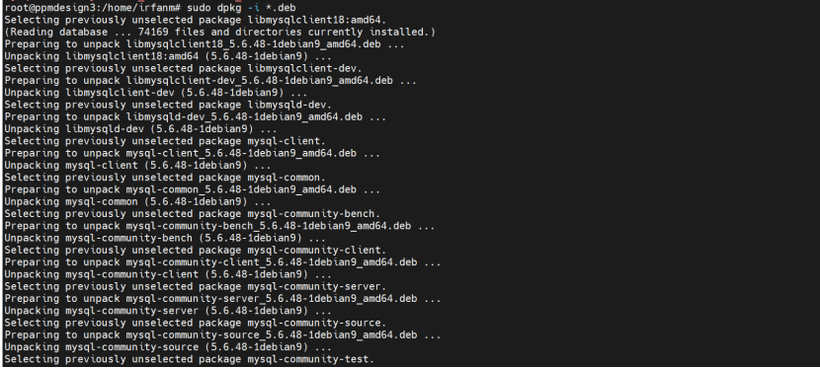

dpkg-deb is a command line tool in Linux used to manipulate Debian package files (which have a .deb file extension). It is part of the dpkg package management system, which is the default package management system for Debian and its derivatives, such as Ubuntu.

The dpkg-deb command can be used to perform a variety of tasks related to Debian package files, including:

* Building Debian package files from a set of files and directories.
* Extracting the contents of a Debian package file to a directory.
* Inspecting the contents and metadata of a Debian package file.
* Installing and uninstalling Debian package files.

2.3.5 Dependency Packages Installation

apt install libaio1 libncurses5 libtinfo5

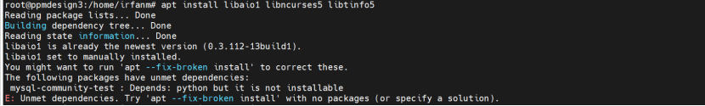

2.3.6 Fix Broken Package

apt --fix-broken install

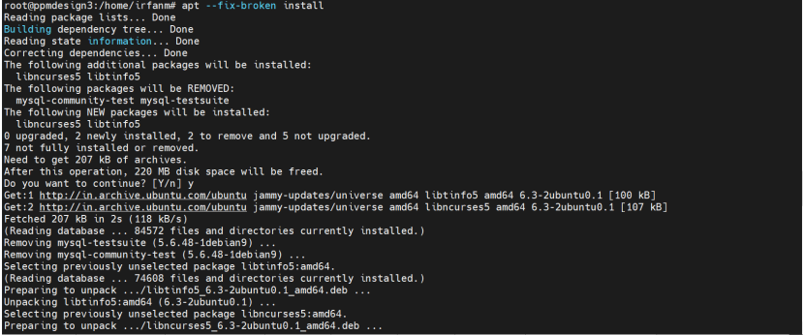

2.3.7 Create Root Password

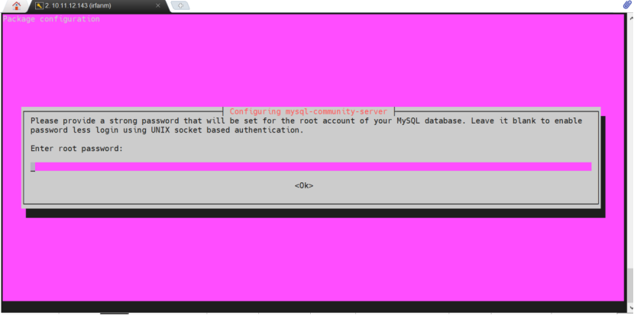

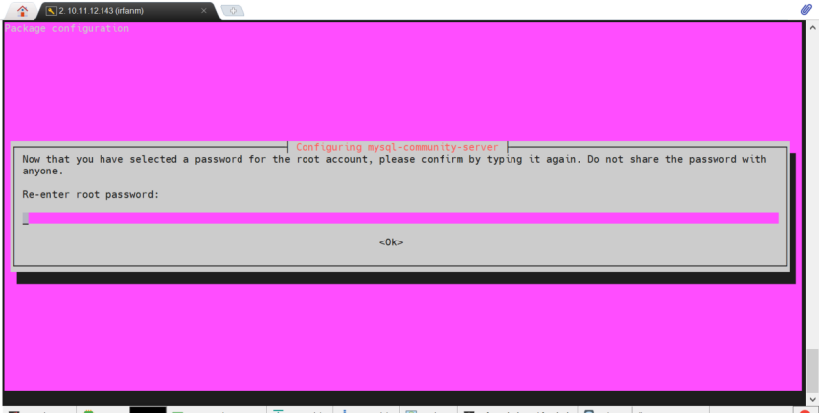

2.3.8 Check Status and Commands

sodu service mysql status // check status

sudo service mysql start // Start MySQL

sudo service mysql stop // Stop MySQL

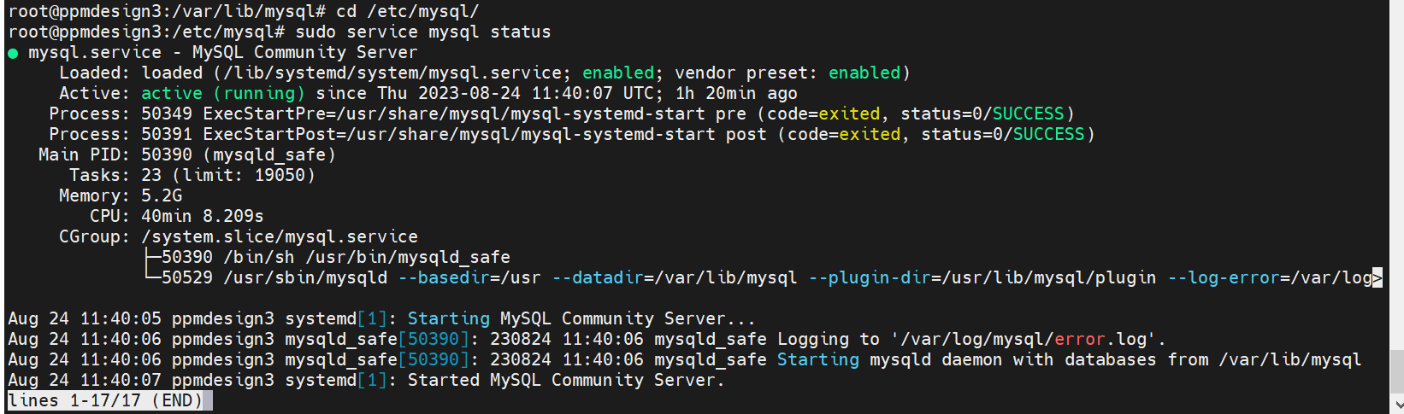

2.3.9 Create Database

create database PPMNewProd;

2.3.10 Extract Database

mysql -u root -p PPMNewProd < /opt/dbbackup/db_BKP_223/23082023_1900_PPMDB.sql

2.3.11 Test Database Connection

2.3.12 Run query and SP to Verify Database

2.4 Apache Tomcat Installation

2.4.1 Check Prerequisite

a. Java 8 installed.

If java is not installed, please refer section 2.1.2 for java installation.

b. Ubuntu package updated.

Refer section 2.1.3 for update.

For more installation, please refer to

<https://vegastack.com/tutorials/how-to-install-tomcat-9-on-ubuntu-22-04/>

2.4.2 Create Tomcat Users and Groups

sudo useradd -m -U -d /opt/tomcat -s /bin/false tomcat

2.4.3 Download Tomcat Installer

cd /tmp

wget <https://downloads.apache.org/tomcat/tomcat-9/v9.0.80/bin/apache-tomcat->9.0.80.tar.gz

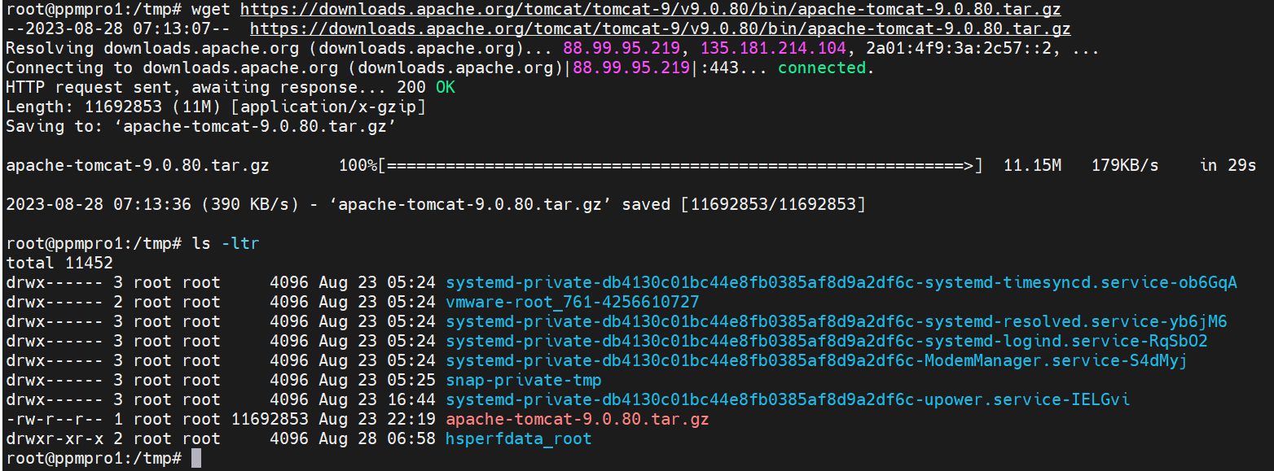

2.4.4 Set Permission

sudo tar -xf apache-tomcat-9.0.80.tar.gz -C /opt/tomcat/

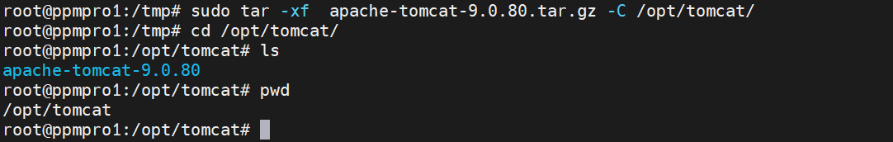

sudo ln -s /opt/tomcat/apache-tomcat-9.0.80 /opt/tomcat/latest



sudo chown -R tomcat: /opt/tomcat

sudo sh -c 'chmod +x /opt/tomcat/latest/bin/*.sh'

2.4.5 Create SystemD unit file

create a tomcat.service unit file in the /etc/systemd/system/ directory.

touch tomcat.service or cat > touch tomcat.service

After that, paste the following configuration in /etc/systemd/system/tomcat.service:

/etc/systemd/system/tomcat.service

[Unit]

Description=Tomcat 9 servlet container

After=network.target

[Service]

Type=forking

User=tomcat

Group=tomcat

Environment="JAVA_HOME=/usr/lib/jvm/java-1.8.0-openjdk-amd64"

Environment="JAVA_OPTS=-Djava.security.egd=file:///dev/urandom -Djava.awt.headless=true"

Environment="CATALINA_BASE=/opt/tomcat/latest"

Environment="CATALINA_HOME=/opt/tomcat/latest"

Environment="CATALINA_PID=/opt/tomcat/latest/temp/tomcat.pid"

Environment="CATALINA_OPTS=-Xms512M -Xmx1024M -server -XX:+UseParallelGC"

ExecStart=/opt/tomcat/latest/bin/startup.sh

ExecStop=/opt/tomcat/latest/bin/shutdown.sh

[Install]

WantedBy=multi-user.target

2.4.6 Check Status and Commands

sudo systemctl daemon-reload

enable the Tomcat service and start it.

sudo systemctl enable --now tomcat



sudo systemctl status tomcat

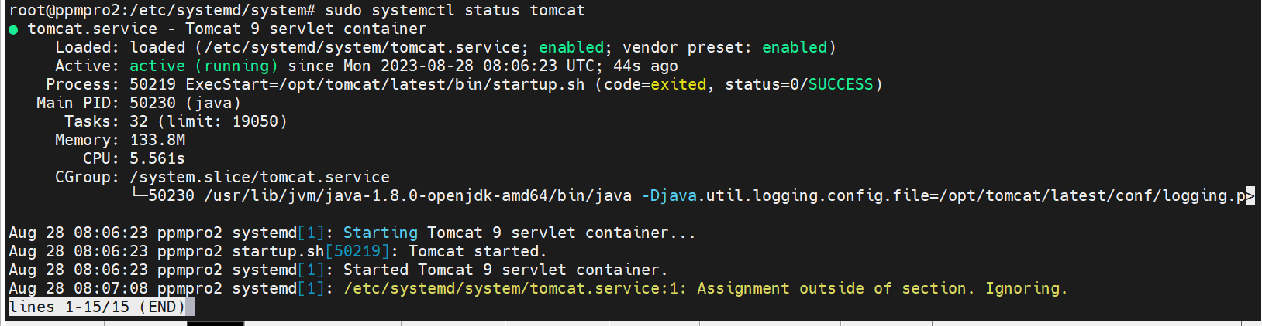

Now you can start, stop, even restart Tomcat as any other systemd service. Use the following command:

sudo systemctl start tomcat  
sudo systemctl stop tomcat  
sudo systemctl restart tomcat

2.4.7 Configure the Firewall

If you wish to access Tomcat from outside the local network, you must open port 8080. To do so, use the following command:

sudo ufw allow 8080/tcp

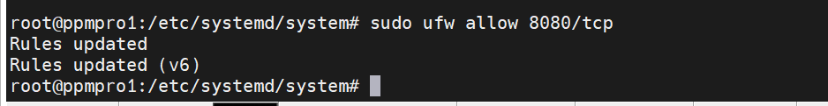

2.4.8 Configure the Web Management Interface

To gain access to the Web Management Interface, you must create a user.

a. Navigate to the tomcat-users.xml file, as this is where Tomcat users and roles are defined.

b. Create a user with both admin-gui and manager-gui roles. This will enable access to the /host-manager/html URL and allow for the creation, deletion, and management of virtual hosts. The manager-gui will also let you deploy and undeployed web-applications without needing to restart the entire container through the /host-manager/html interface.

c. Open the tomcat-users.xml file. Create a new user with the following command:

sudo vim /opt/tomcat/latest/conf/tomcat-users.xml

<tomcat-users>  
<!--Comments-->  
<role rolename="admin-gui"/>  
<role rolename="manager-gui"/>  
<user username="admin" password="admin_password" roles="admin-gui,manager-gui"/>  
</tomcat-users>

To access the web interface from a remote IP, remove the restrictions. However, this is not recommended for production systems, as it may have security implications.

You must enable access to the web interface from any location. To do this, open the following two files and comment out or remove the following lines:

For Manager app:

sudo nano /opt/tomcat/latest/webapps/manager/META-INF/context.xml



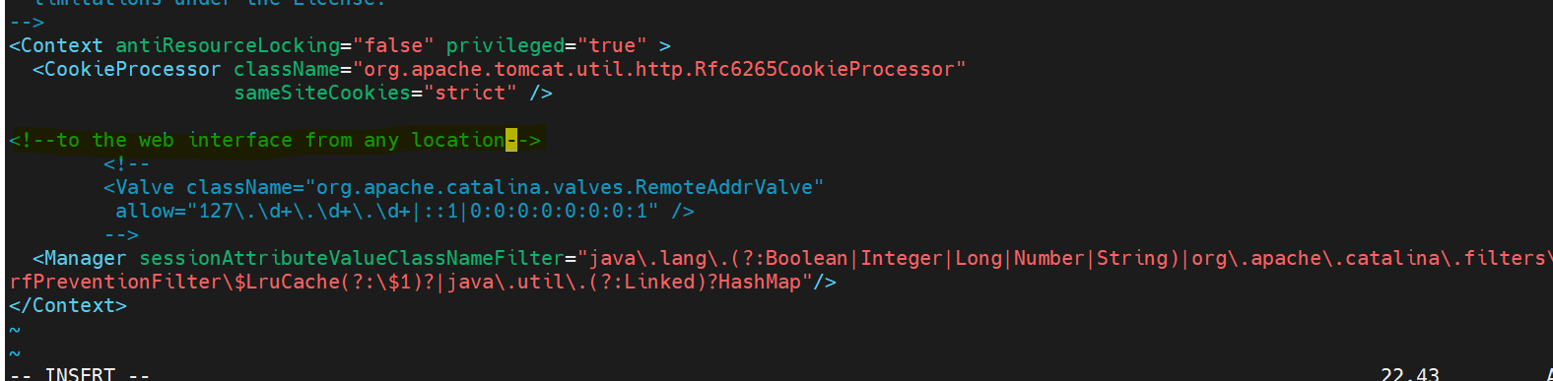

For Host Manager app:

sudo nano /opt/tomcat/latest/webapps/host-manager/META-INF/context.xml



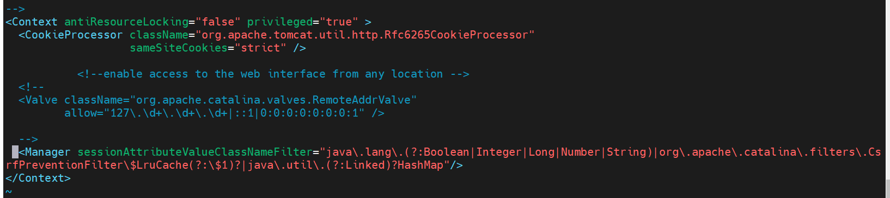

If you want to restrict access to the web interface to a specific IP, add the address to the list.

Use | to separate the IP addresses in the list. You can add a single IP address or can also use a regular expression.

After that, restart the Tomcat service to apply the changes.

2.4.9 Testing Tomcat

1) Proceed to open the browser, then type

http://<your_domain_or_IP_address>:8080.

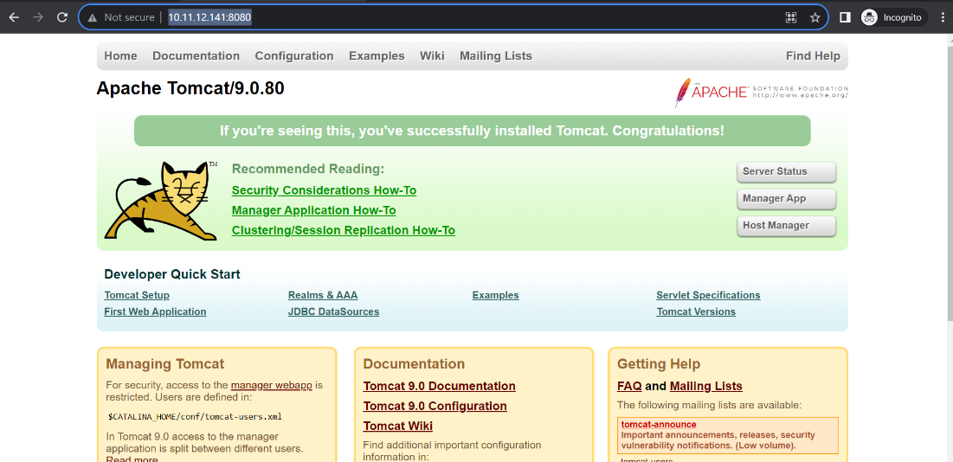

2) The Tomcat web application manager will be accessible at:

http://<your_domain_or_IP_address>:8080/manager/html

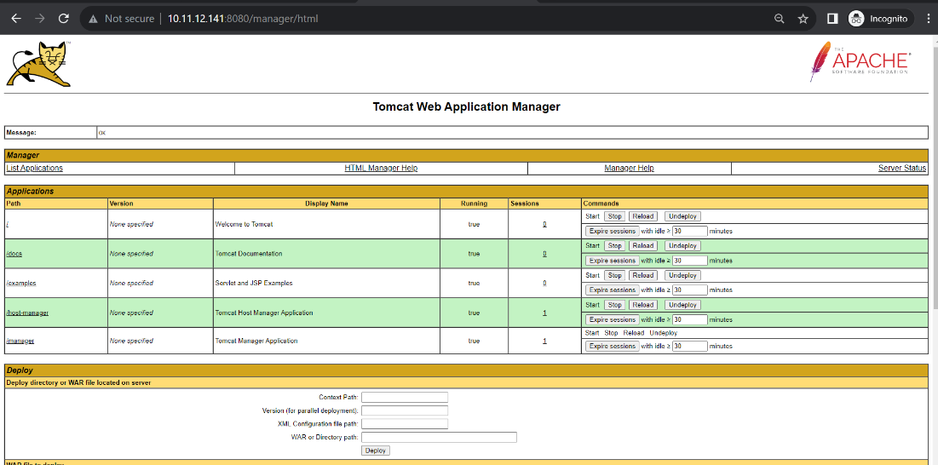

3) Moreover, the Tomcat Virtual Host Manager can be accessed at:

http://<your_domain_or_IP_address>:8080/host-manager/html

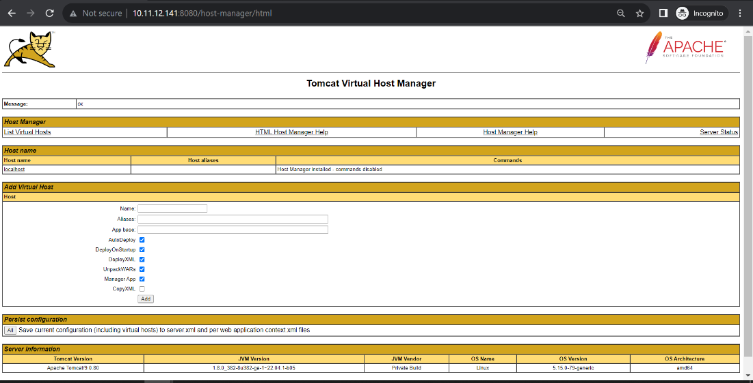

2.5 Nginx Installation

2.5.1 Check Prerequisite

a. Java 8 installed.

If java is not installed, please refer section 2.1.2 for java installation.

b. Ubuntu package updated.

Refer section 2.1.3 for update.

2.5.2 Install Nginx

sudo apt install nginx

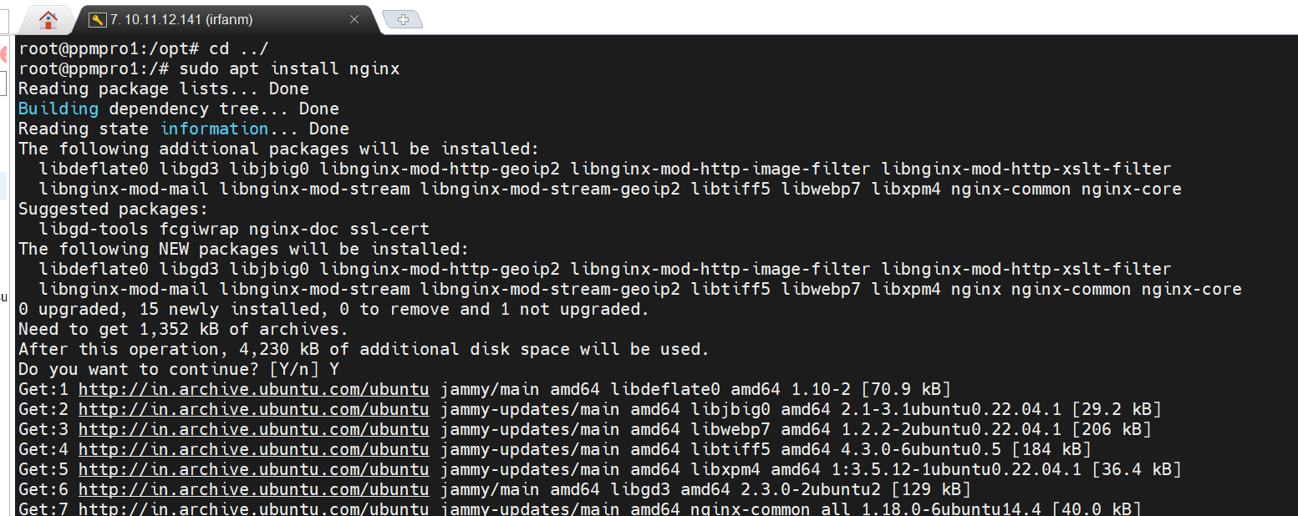

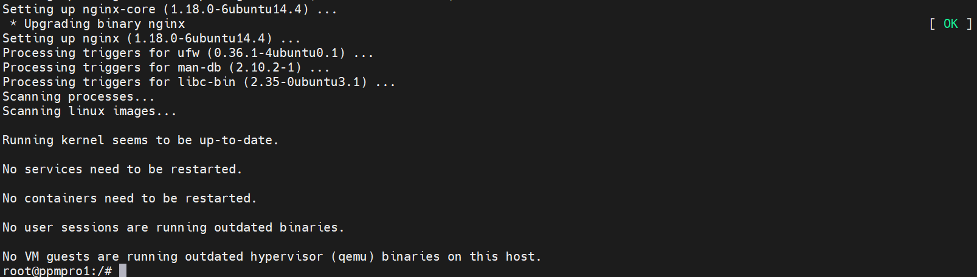

2.5.3 Verify Installation

nginx -v

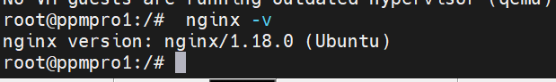

2.5.4 Check Status and Commands

sudo systemctl status nginx

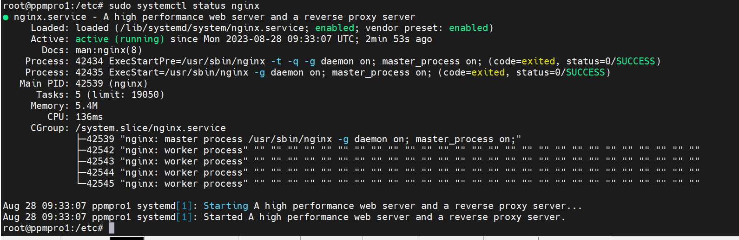

Restart and start the NGINX service by using the following command

$ sudo systemctl restart nginx  
$ sudo systemctl start nginx

Enable the NGINX service to start the service at the startup of the system automatically:

sudo systemctl enable nginx



2.5.5 Configure Firewall

Now, you need to configure the firewall to allow traffic on HTTP port 80 and HTTP port 443. You can use the following command to get the traffic on both ports for NGINX:

sudo ufw allow 'Nginx full'

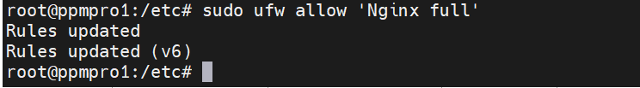

Reload the firewall to adapt to the changes:

sudo ufw reload

2.5.6 Test Connection

sudo nginx -t

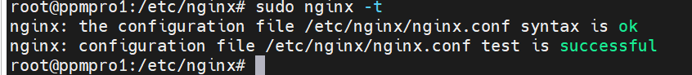

Once the NGINX is installed and configured properly. You can use the following address in the browser to check whether NGINX is running or not:

http://127.0.0.1

Or you can get the result on the terminal via the following command:

$ curl -i 127.0.0.1

2.5.7 Modify Nginx Configuration

sudo vim /etc/nginx/nginx.conf

Within the http block, add the following server block to allow access to specific IP addresses or networks:

server {  
 listen 80;  
 server_name example.com;  
 allow 192.168.1.0/24;  
 deny all;  
 # ...  
}

Replace example.com with your domain name, and 192.168.1.0/24 with the IP address or network that you want to allow access from.

To deny access to specific IP addresses or networks, use the deny directive instead of allow all.

2.5.8 Nginx Configuration for React Code Hosting

cat /etc/nginx/sites-enabled/ppmRewrite_prod

server {

listen 3000;

listen [::]:3000;

root /var/www/ppm;

index index.html index.htm index.nginx-debian.html;

server_name 10.11.12.141;

location / {

try_files $uri $uri/ /index.html;

}

}

server{

listen *:80;

server_name ppmiams.prolifics.com;

return 301 https://$server_name$request_uri/;

}

server{

listen *:80;

server_name http://ppmiams.prolifics.com;

return 301 https://ppmiams.prolifics.com$request_uri/;

}

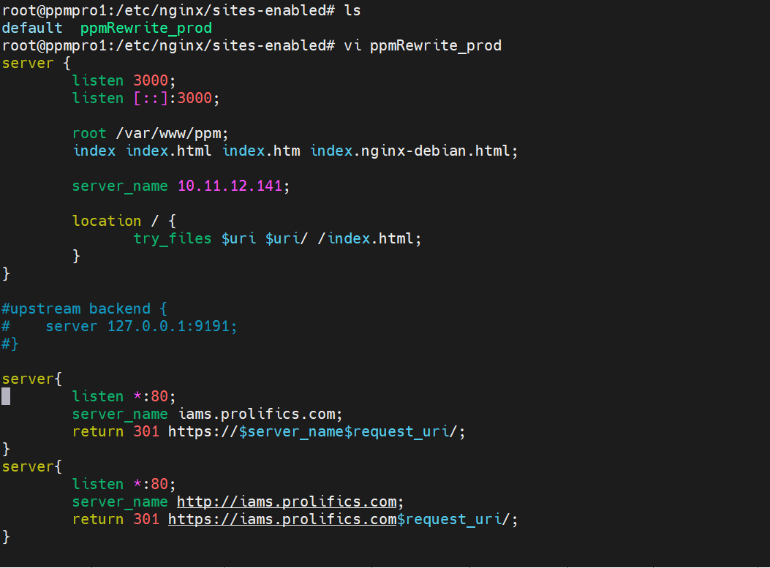

2.5.8 Remove Nginx

sudo apt autoremove nginx --purge

2.6 Podman Installation

2.6.1 Check Prerequisite

a. Java 8 installed.

If java is not installed, please refer section 2.1.2 for java installation.

b. Ubuntu package updated.

Refer section 2.1.3 for update.

2.6.1 Install Podman

sudo apt install podman

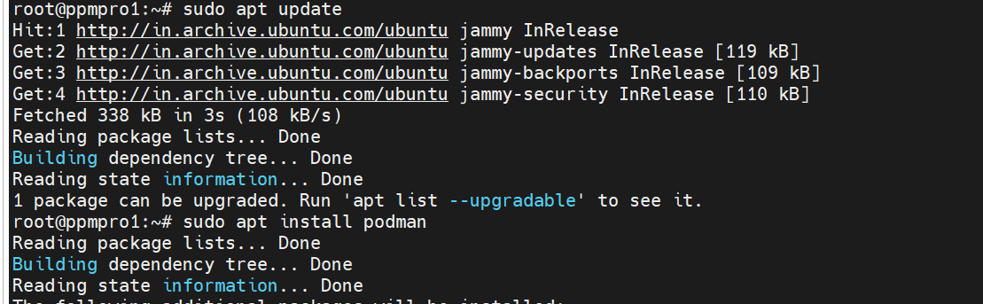

2.6.1 Check Status and Commands

podman –v

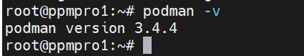

**3.Deployment**

3.1 React Code Hosting

3.1.1 Copy Build file on Server.

Get build file for dev team and copy on server home directory via WinSCP.

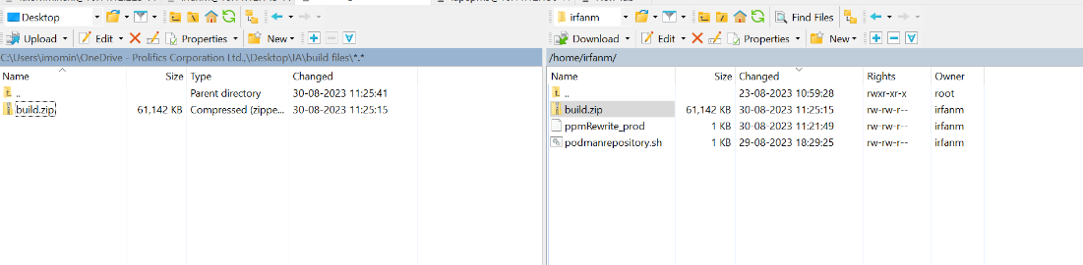

3.1.2 Unzip and rename file as ppm.

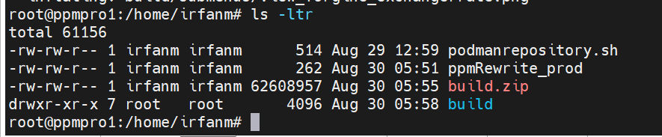

3.1.3 Copy file on /var/www location.

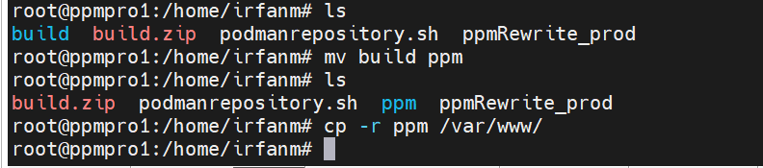

3.1.4 Reload Nginx.

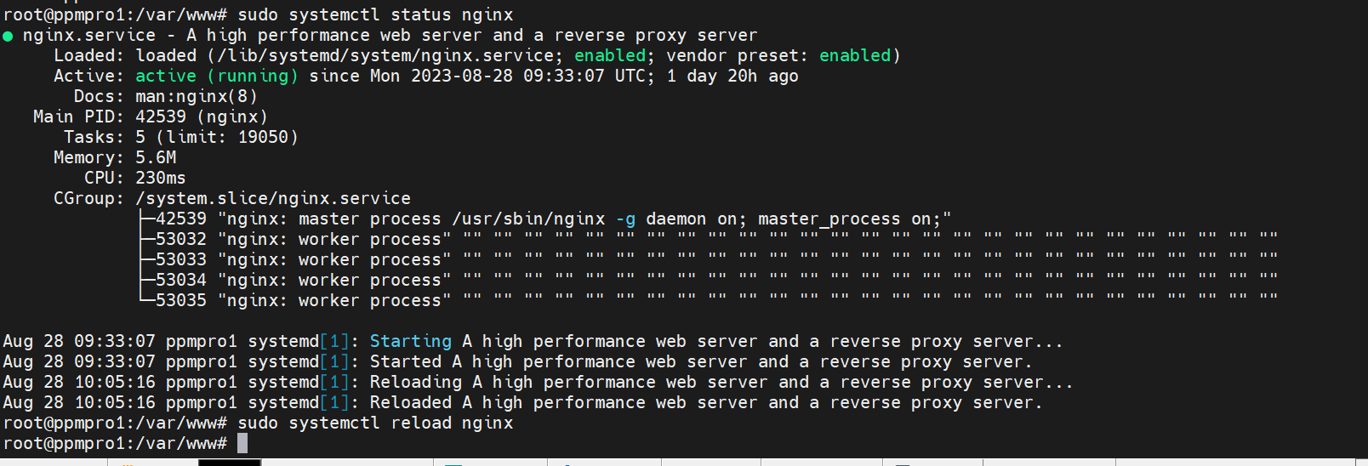

3.1.5 Check browser.

10.11.141:3000

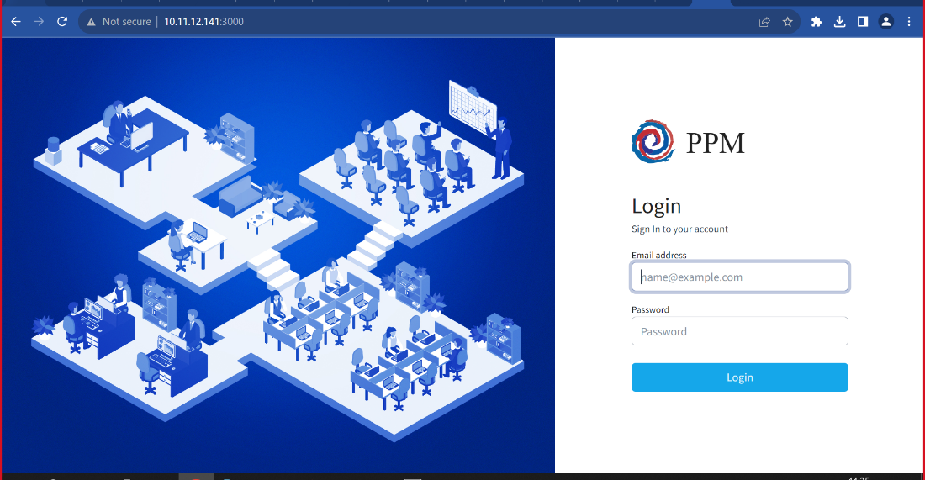

3.2 Podman Deployment

3.2.1 Create required directories.

a. Switch to /opt directory.

cd /opt

b. Create directory name podmaninstall.

mkdir podmaninstall

c. Under podmandinstall create directory name APIGatway.

mkdir APIGatway

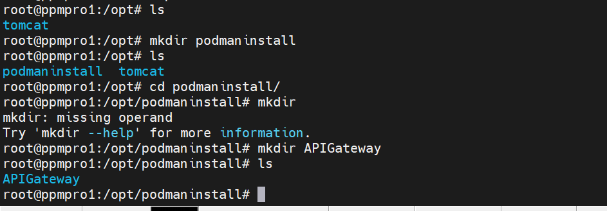

d. Create Podmanfile under APIGateway directory.

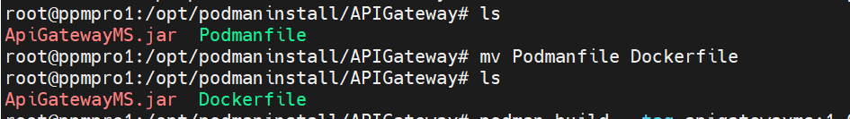

c. Edit Podmanfile / Dockerfile

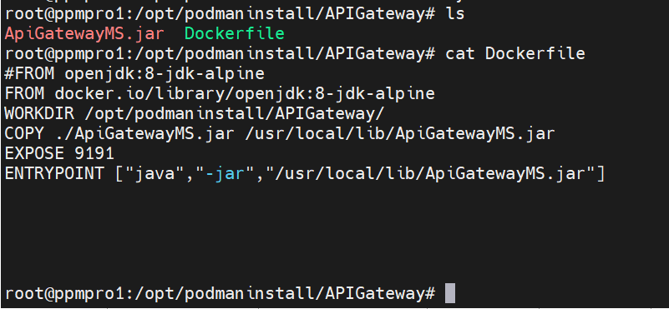

3.2.2 Copy Jar.

Copy .jar file to /opt/podmaninstall/APIGateway location.

3.2.3 Build image.

podman build -t apigatewayms:1.0 .

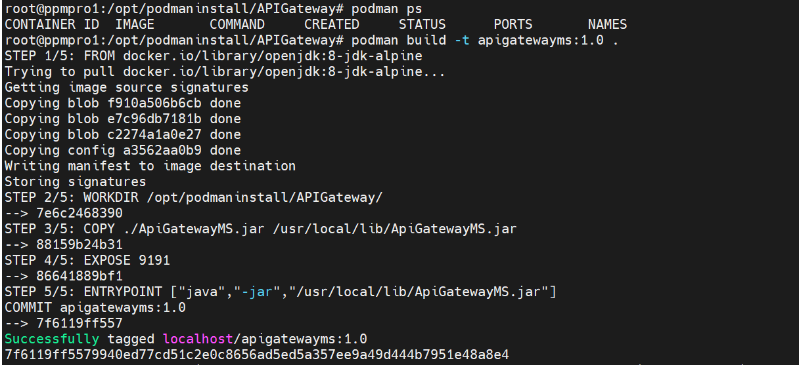

3.2.4 Run Image.

Check configured port to podman

podman port --all

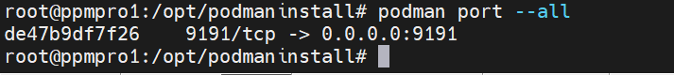

podman run -d -p 9191:9191 --name=apigatewayms apigatewayms:1.0



3.2.5 Check Image.

podman ps



3.3 Microservices deployment

Microservices are deployed on the Application layer , here our application layer is on 10.11.12.142 server.

The development team shared microservices artifacts which are in .war file extensions.

3.3.1 Manual deployment through Tomcat Manager.

a. Login tomcat manger 10.11.12.142:8080/manager/html

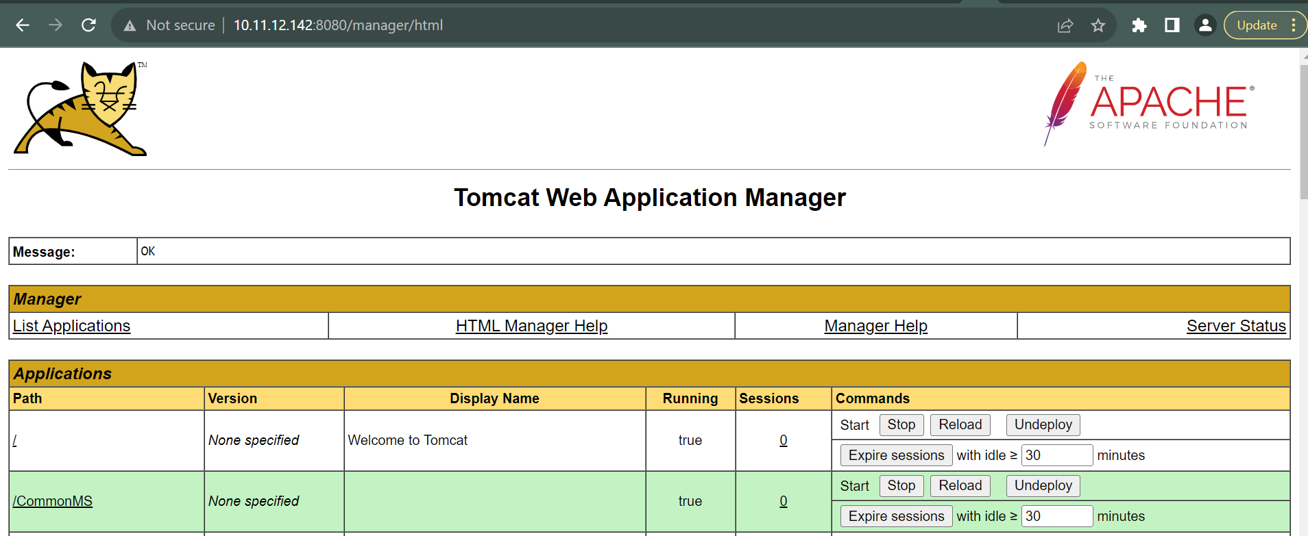

b. Choose .war from local to deploy.

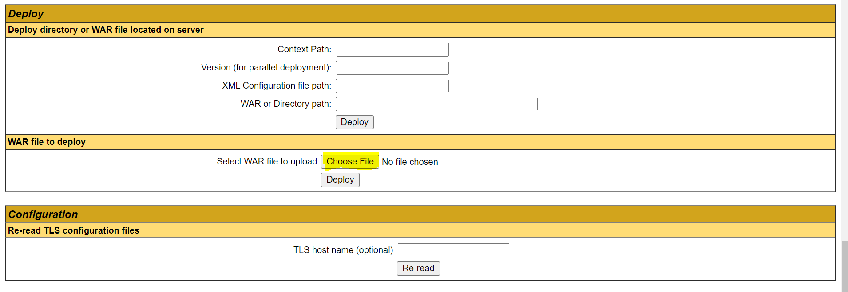

c. Click on deploy.

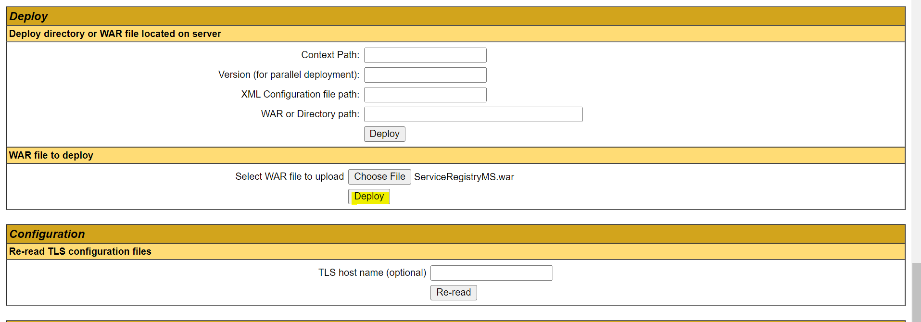

d. Check the status.

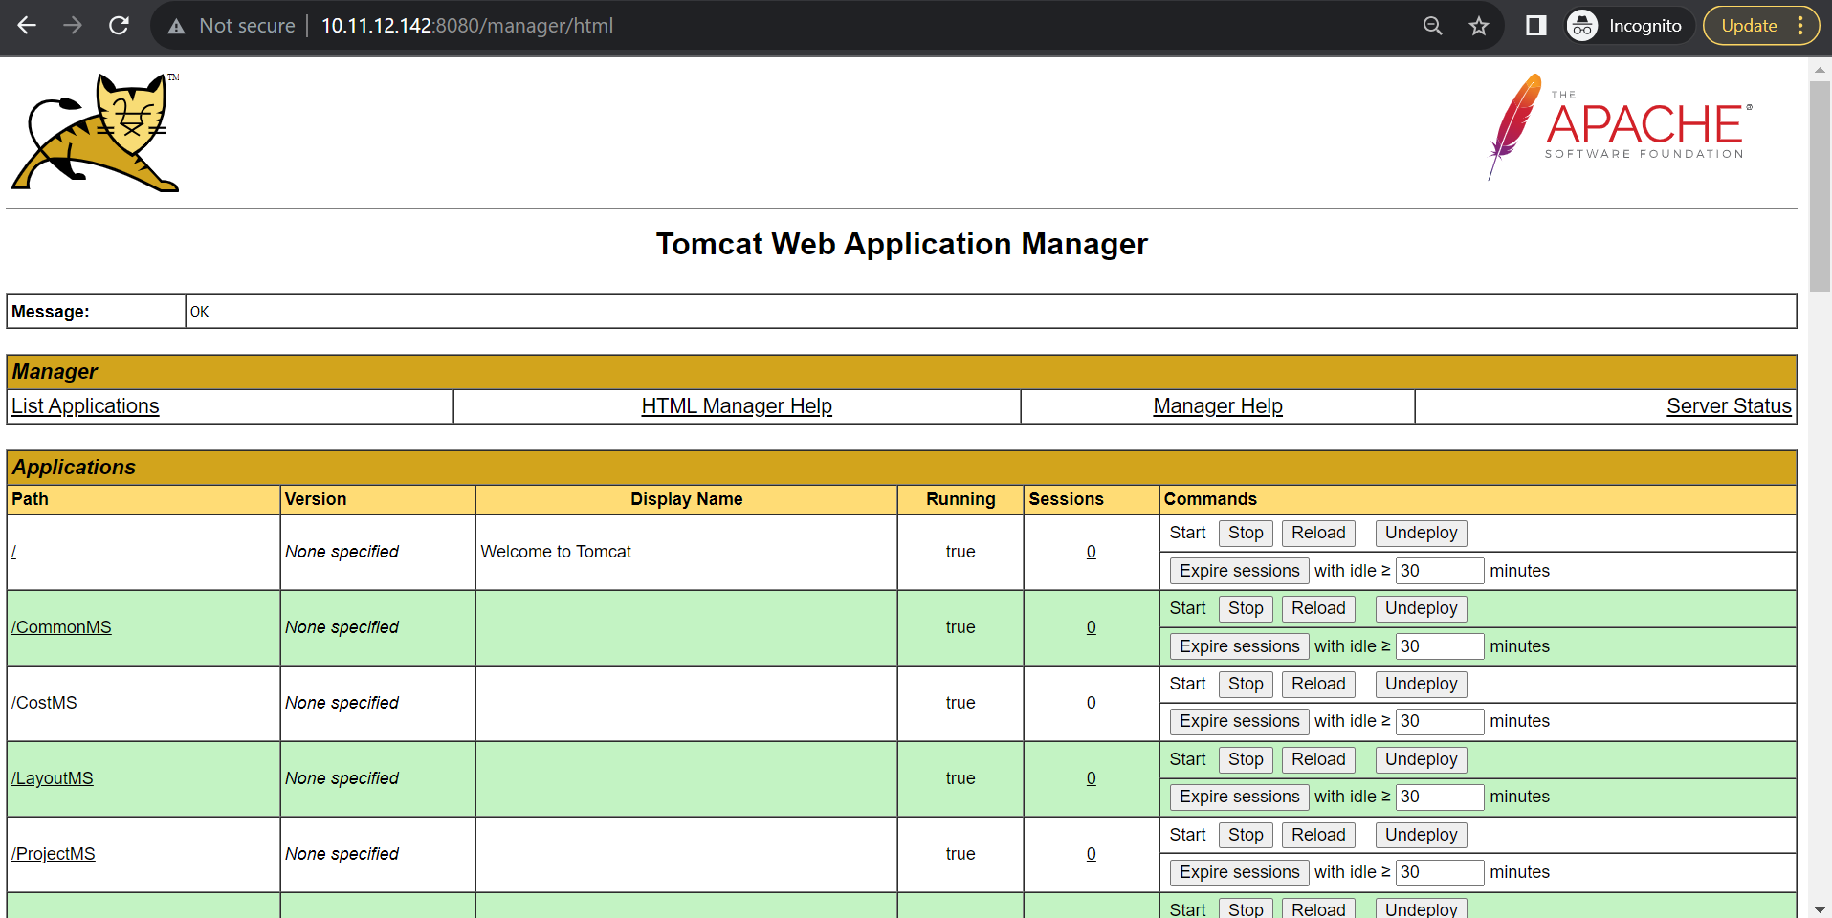

3.3.1 Automatic deployment through Jenkins.

a. Configure Jenkins with SVN repository.

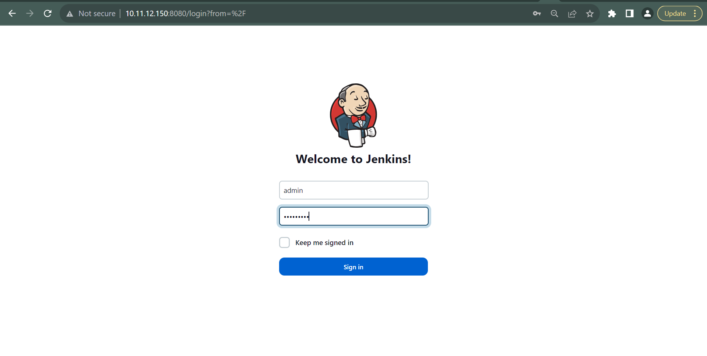

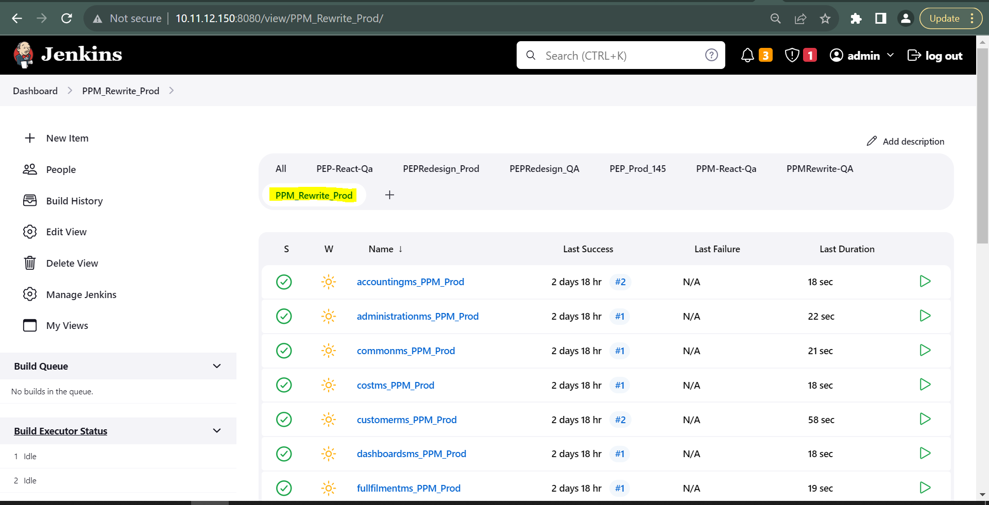

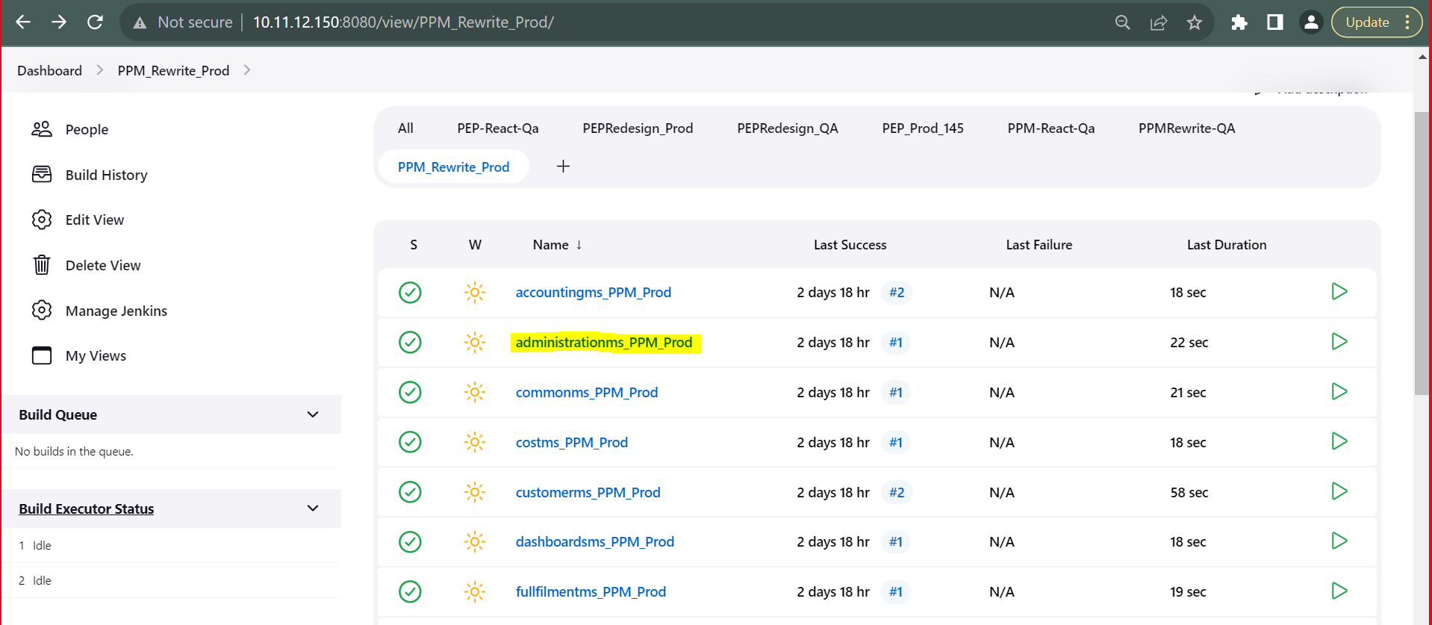

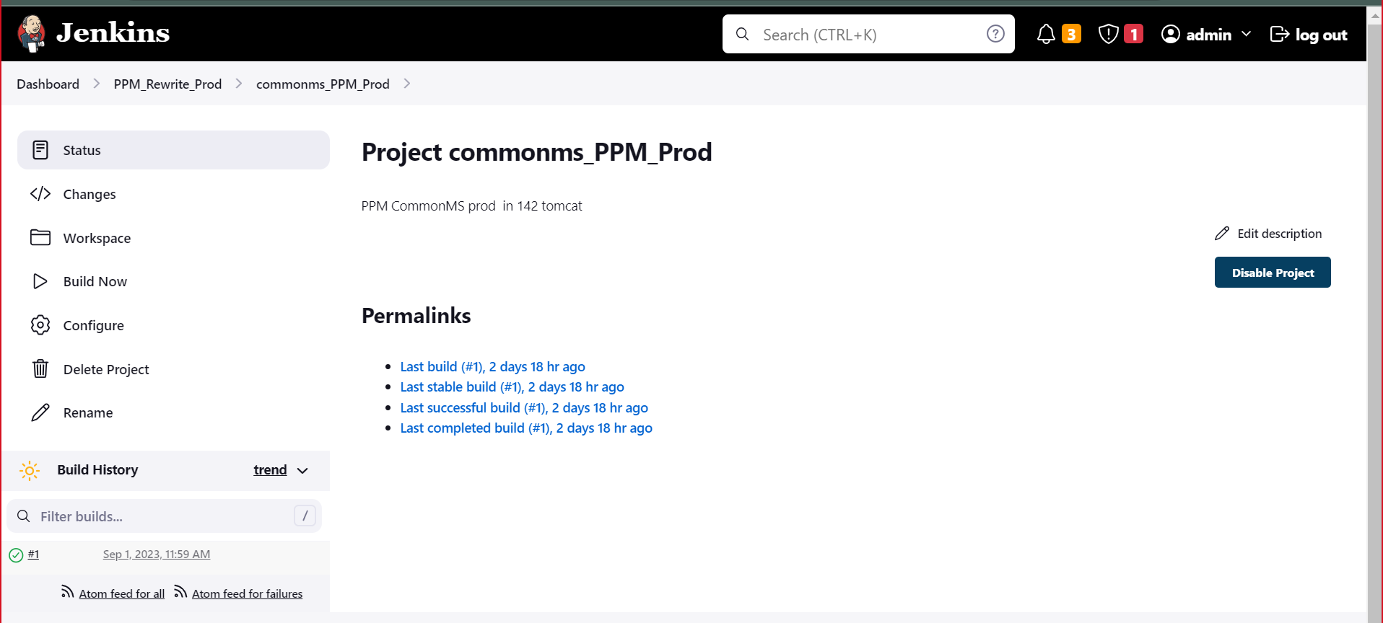

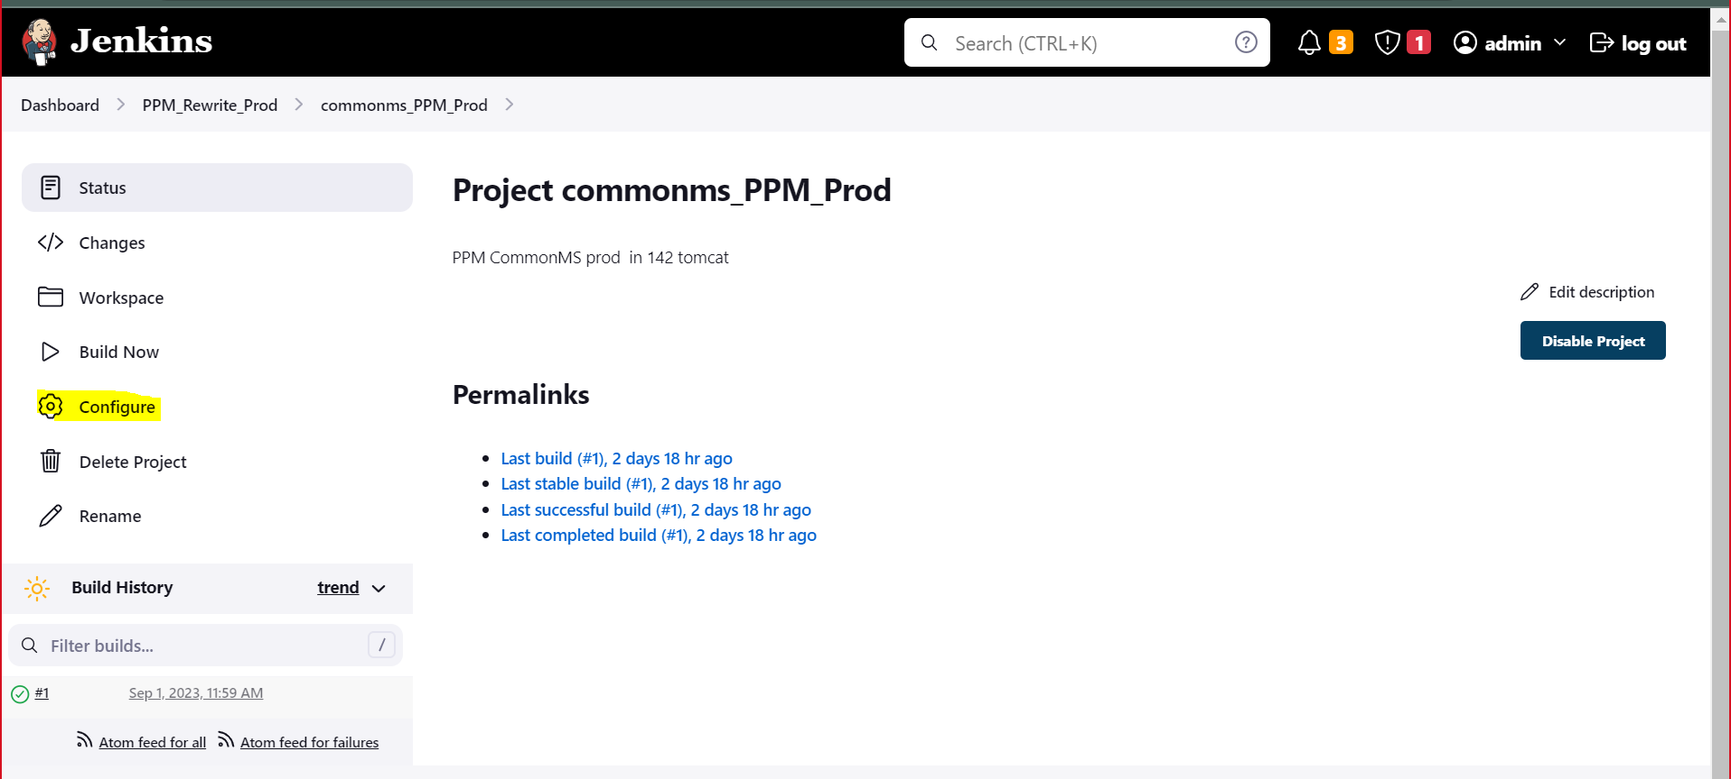

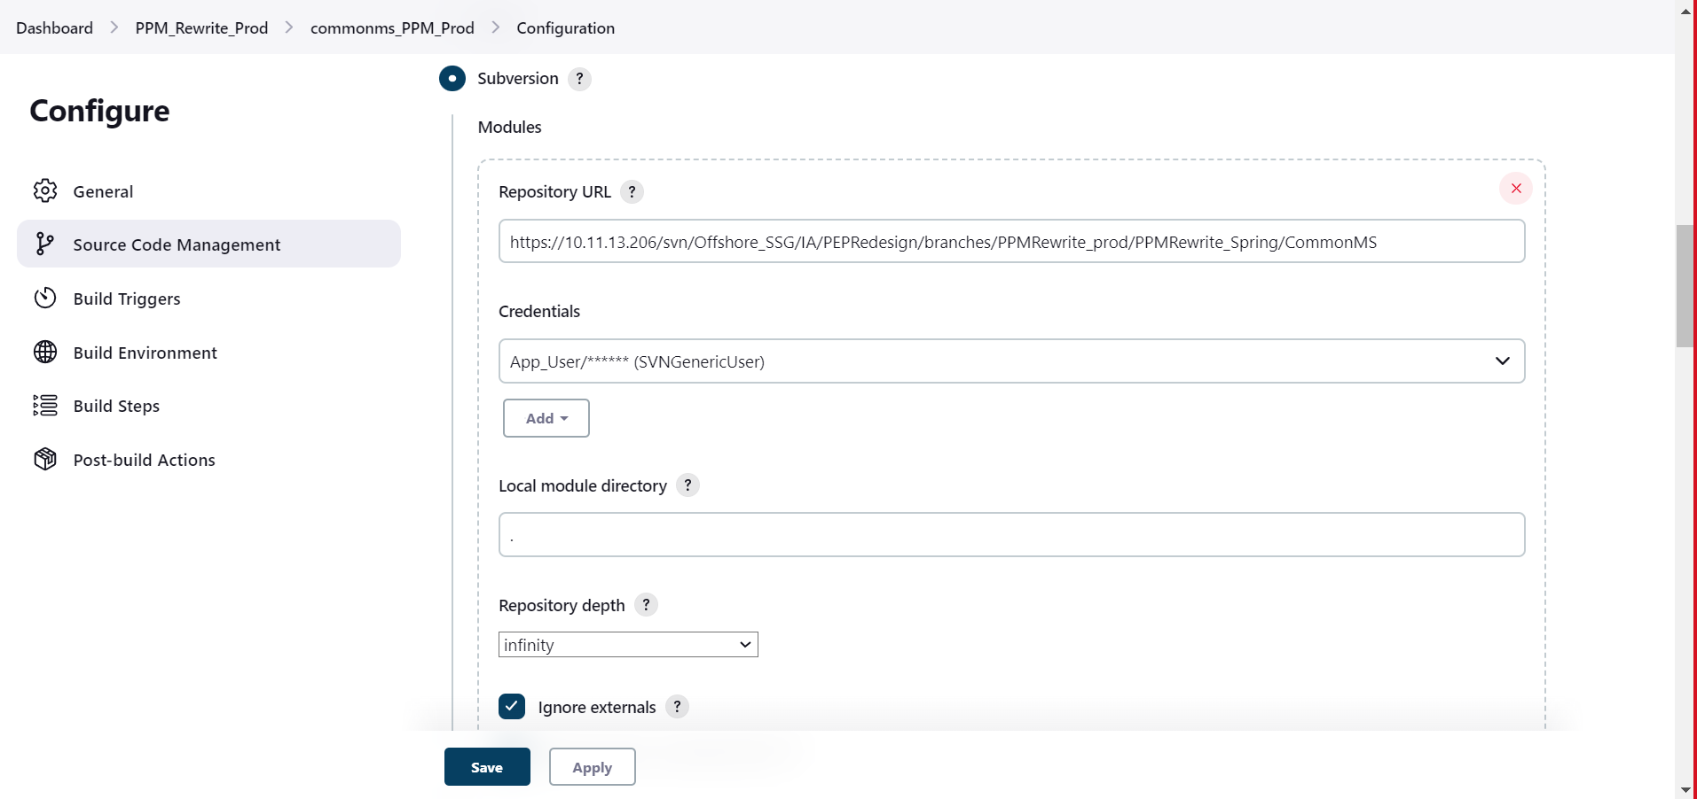

b. Configure Jenkins with Application server to execute.

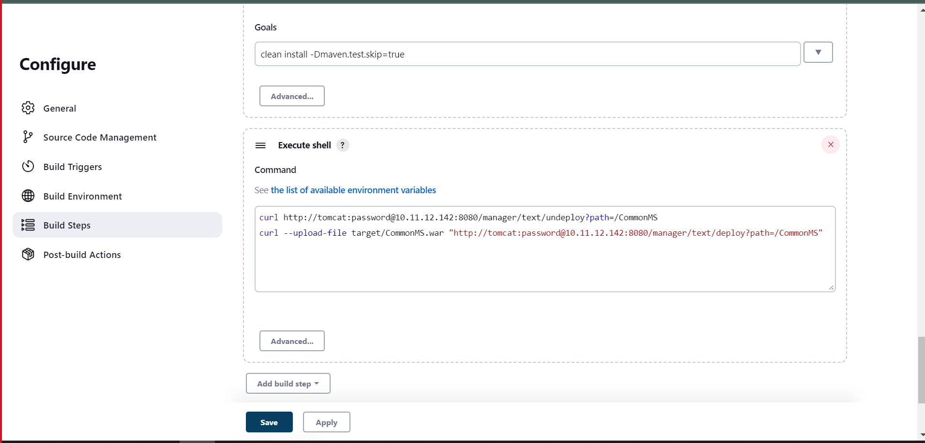

b. Deploy

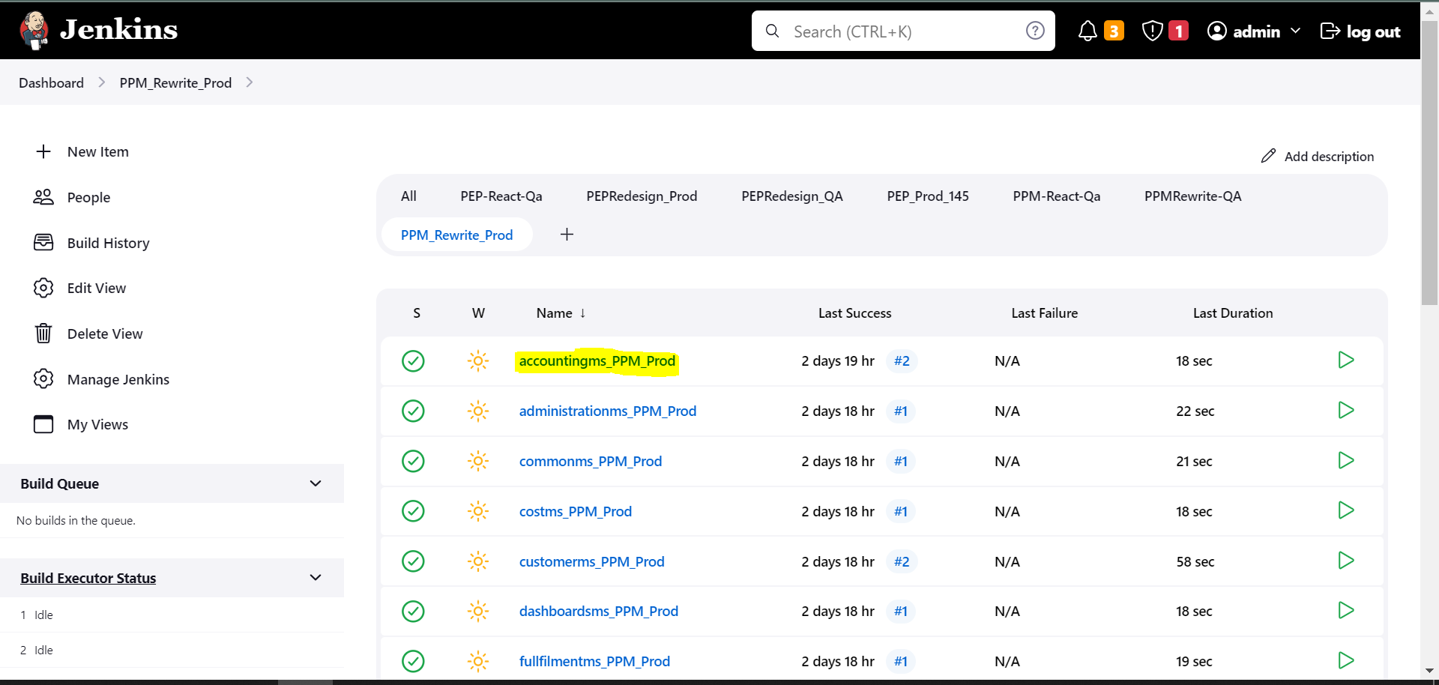

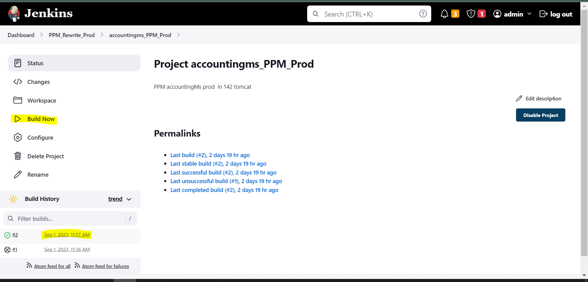

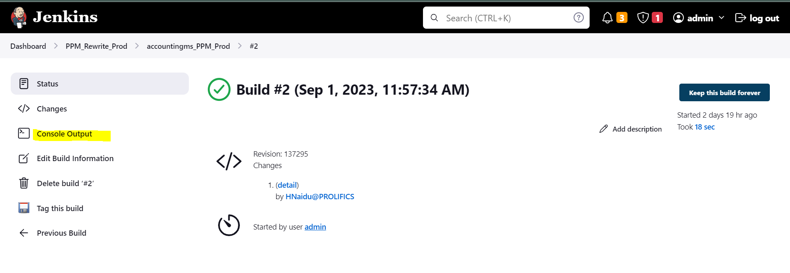

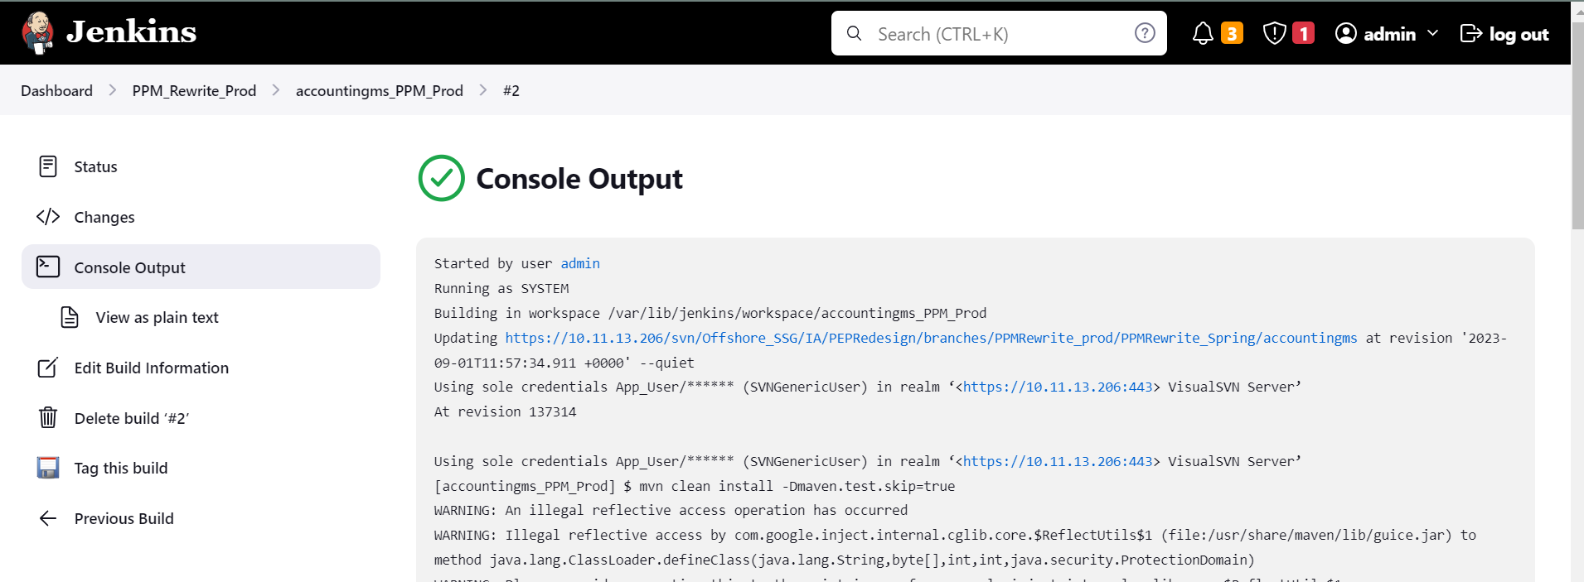

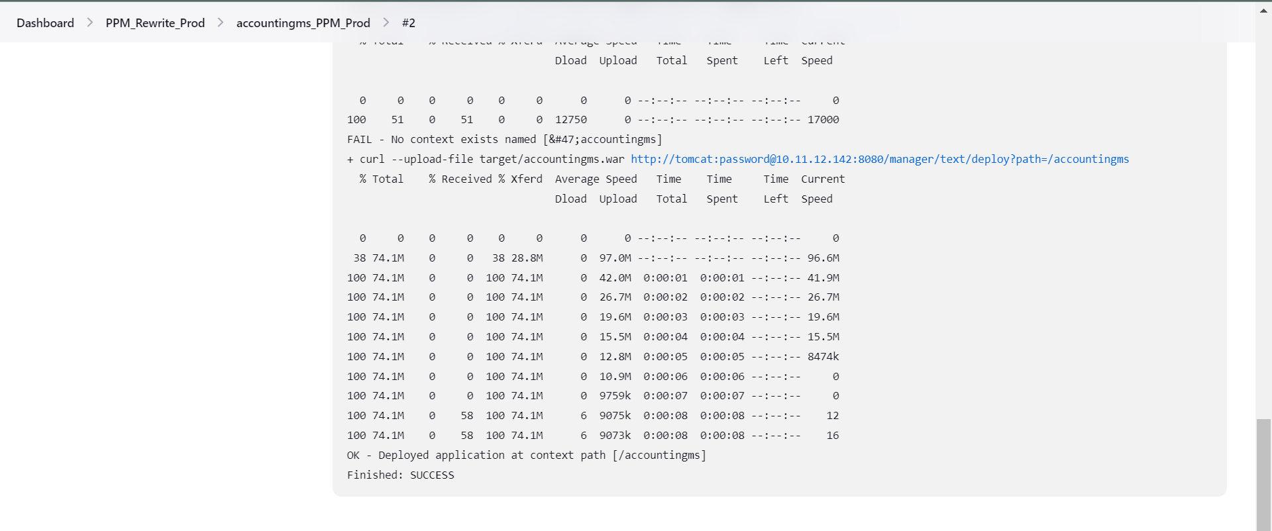

**4.Testing**

4.1 Black box Testing

Black-box testing is a type of software testing in which the tester is not concerned with the internal knowledge or implementation details of the software, but rather focuses on validating the functionality based on the provided specifications or requirements.

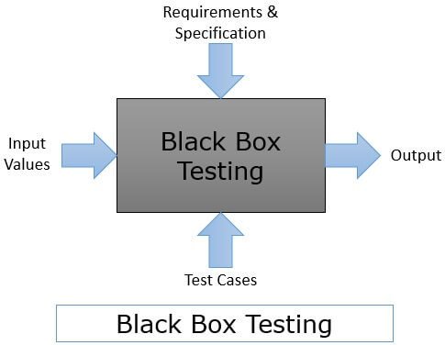

4.1.1 UI Testing

UI Testing (User Interface Testing) is a technique that ensures the UI of a website application is user-friendly and meets the expected customer or end-user requirements. It validates the visual design and layout, and functionality of the user interface to make sure it performs as intended.

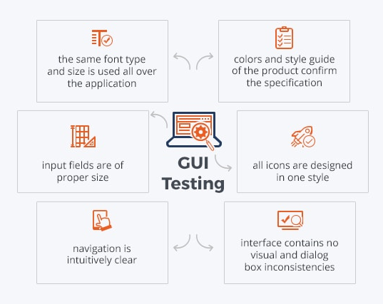

4.1.2 Functionality Testing

Functional testing is a stage in the software delivery lifecycle (also referred to as a 'process') in which quality engineers verify whether the application under test's features behaves as per their requirements.

4.1.3 Performance Testing

Performance Testing is a type of software testing that ensures software applications perform properly under their expected workload. It is a testing technique carried out to determine system performance in terms of sensitivity, reactivity and stability under a particular workload.